(○)目標：如下新生名冊：
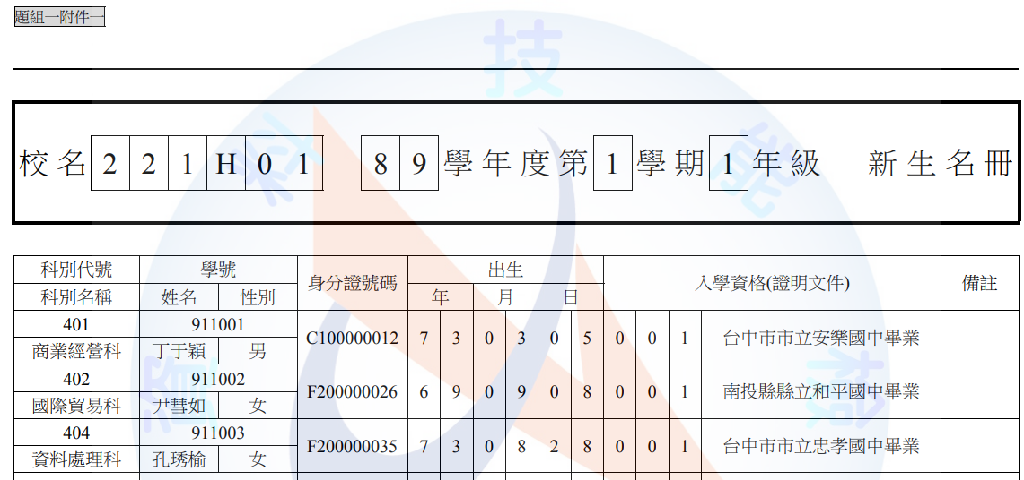

(一)製作標題：
,
校名,2,2,1,H,0,1,,8,9,學年度,第,1,學期,1,年級, ,新生名冊
,
將「如上三列用逗號分隔的文字」用「文字轉換為表格/欄寬自動依內容調整」轉成表格如下：
校名 | 2 | 2 | 1 | H | 0 | 1 |  | 8 | 9 | 學年度 | 第 | 1 | 學期 | 1 | 年級 |  | 新生名冊

(二)製作欄位標題如下：
科別代號 | 學號 |  | 身分證字號 | 出生 |  |  | 入學資格(證明文件) |  |  |  | 備註
科別名稱 | 姓名 | 性別 |  | 年 | 月 | 日

(三)準備資料來源如下：

(2B)用如下指令新增一查詢：

SELECT [科別], [班級座號], [學號], [姓名], [身分證號碼] , mid([身分證號碼],2,1) as sex, [出生年月日],mid([出生年月日],1,4)-1911 as yy , mid([出生年月日],6,2) as mm, mid([出生年月日],9,2) as dd,[畢業國中] ,right([畢業國中],2) as 入學資格 FROM STUDENTS

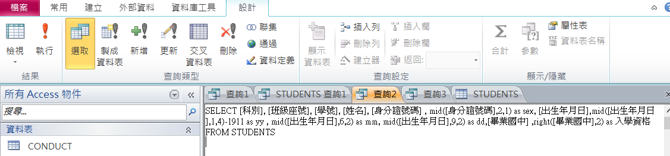

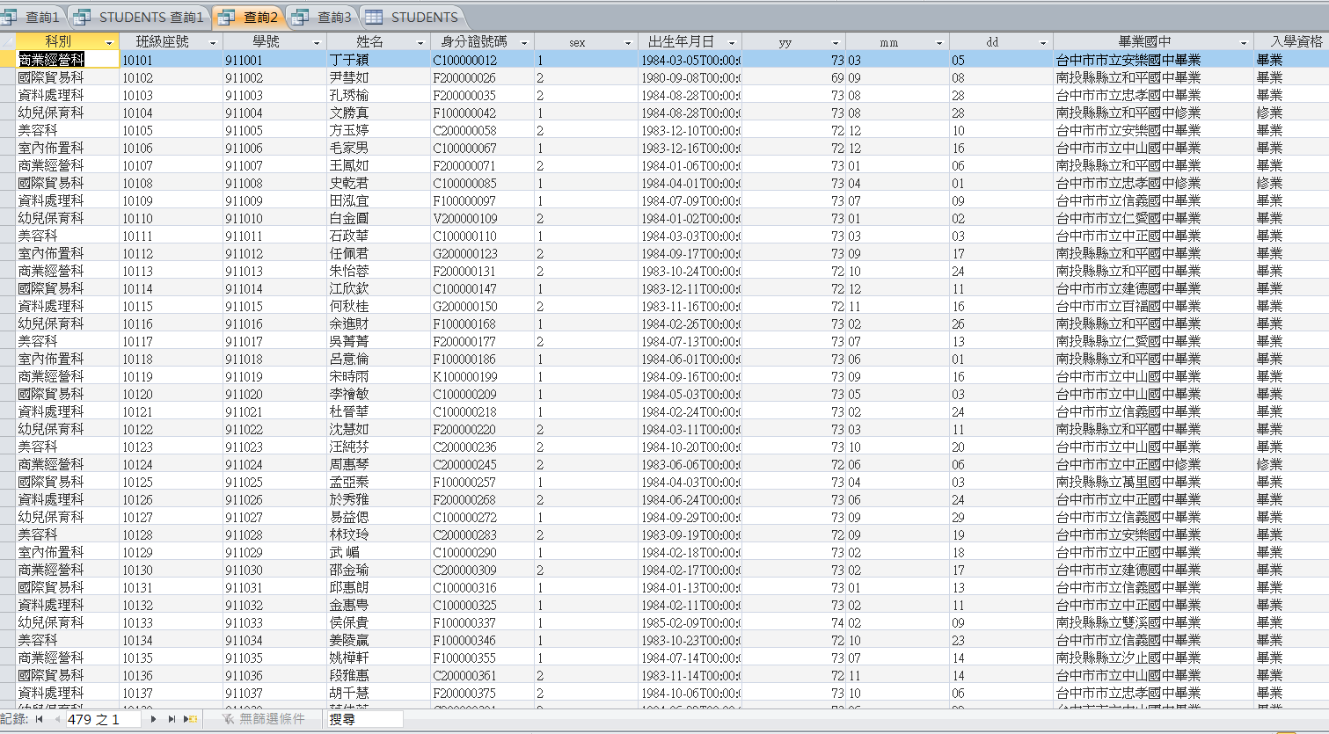

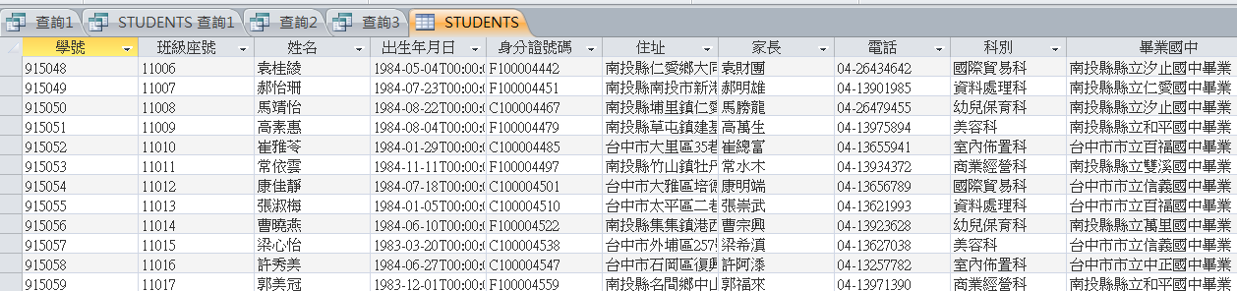

SELECT [科別] , iif([科別]= '商業經營科','401','x0x') as 科別代號 , [學號], [姓名], [身分證號碼] , iif(mid([身分證號碼],2,1)='1','男','女') as sex,mid([出生年月日],1,4)-1911 as yy , mid([出生年月日],6,2) as mm, mid([出生年月日],9,2) as dd,right([畢業國中],2) as 入學資格 ,iif(right([畢業國中],2)='畢業','001','004') as 入學資格代號 FROM STUDENTS
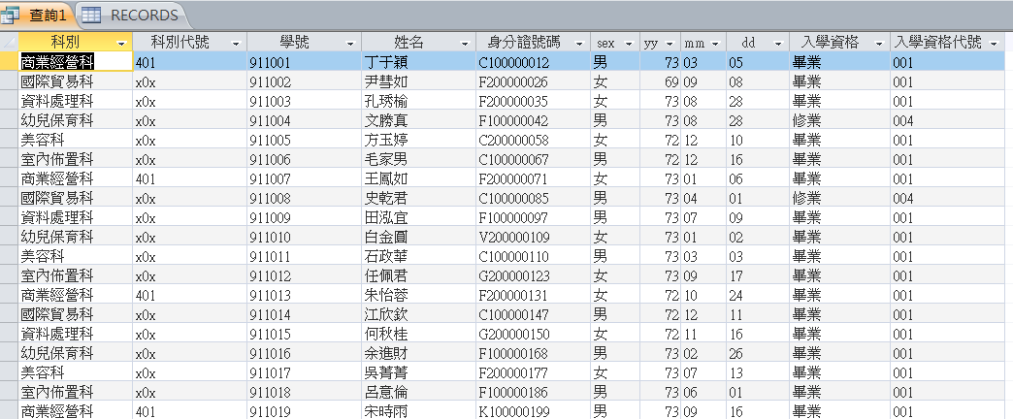

SELECT [科別], [班級座號], [學號], [姓名], [身分證號碼] , mid([身分證號碼],2,1) as sex, [出生年月日],mid([出生年月日],1,4)-1911 as yy , mid([出生年月日],6,2) as mm, mid([出生年月日],9,2) as dd,[畢業國中] ,right([畢業國中],2) as 入學資格 FROM STUDENTS
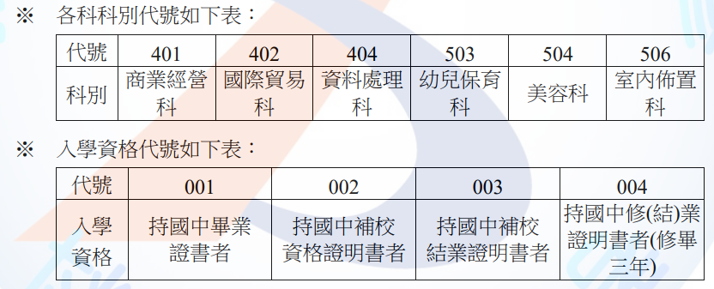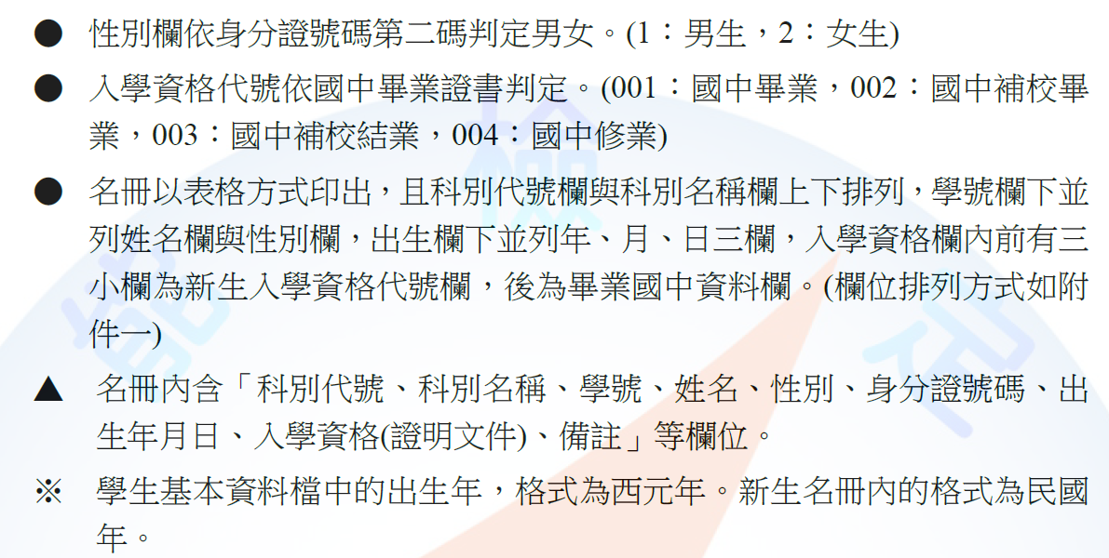

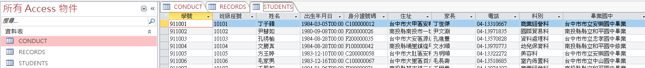
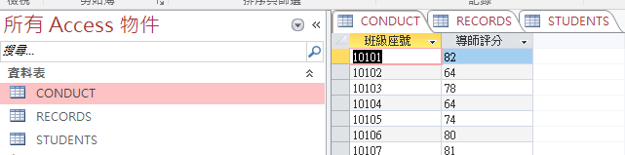
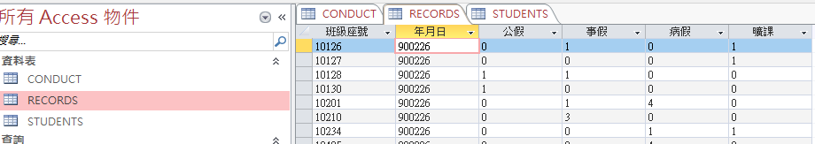

Select sum([事假]) as T, sum([病假]) as S, sum([公假]) as P , sum([曠課]) as X from records where left([班級座號],3)="101" and mid([年月日],3,2)="03"
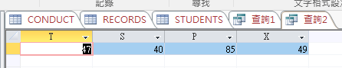

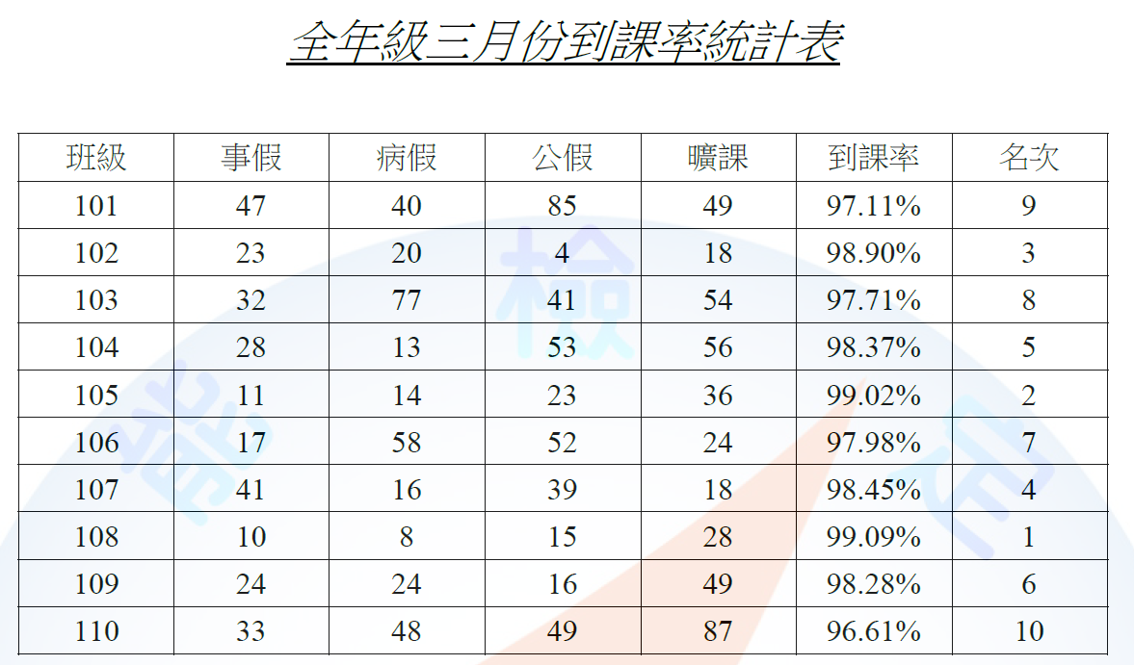

SELECT left([班級座號],3) as 班級, sum([事假]) AS 事, sum([病假]) AS 病, sum([公假]) AS 公, sum([曠課]) AS 曠 FROM records WHERE mid([年月日],3,2)="03" group by left([班級座號],3) order by left([班級座號],3);
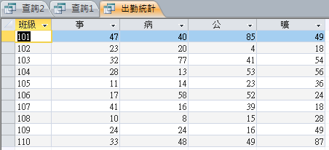

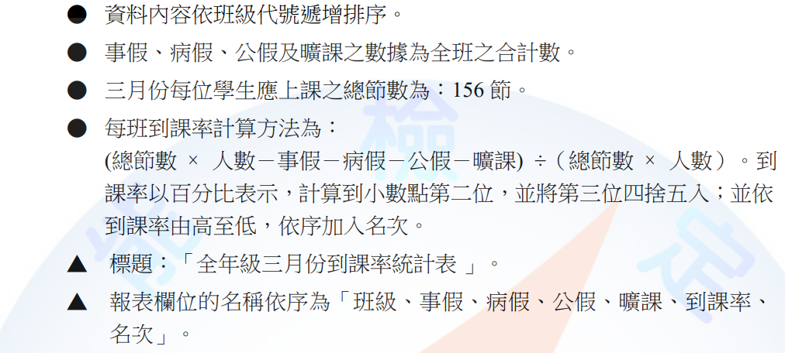

SELECT left([班級座號],3) as 班級,count([學號]) as 人數, 156*count([學號]) as 總節數人數 FROM STUDENTS group by left([班級座號],3) order by left([班級座號],3);

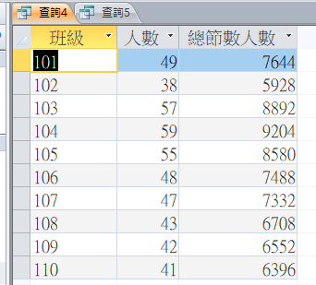

SELECT left([班級座號],3) AS 班級, sum([事假]) AS 事, sum([病假]) AS 病, sum([公假]) AS 公, sum([曠課]) AS 曠
into TSPXcount
FROM records
WHERE mid([年月日],3,2)="03"
GROUP BY left([班級座號],3)
ORDER BY left([班級座號],3);
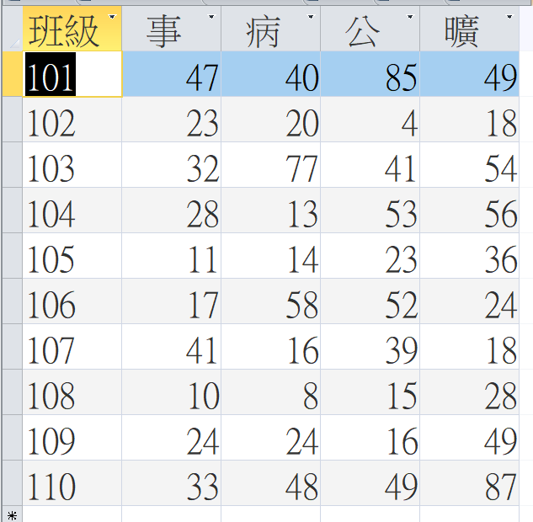

SELECT left([班級座號],3) AS 班級, count([學號]) AS 人數, 156*count([學號]) AS 總節數人數
into classCount
FROM STUDENTS
GROUP BY left([班級座號],3)
ORDER BY left([班級座號],3);
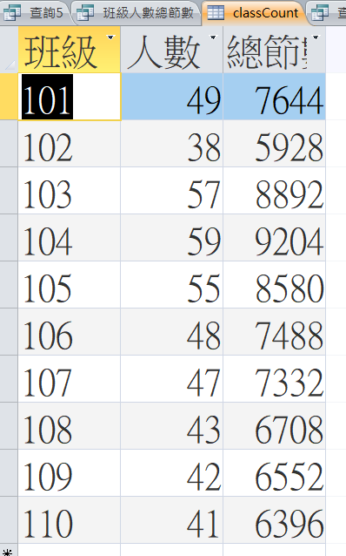

select * from TSPXcount as a, classcount as b where a.班級=b.班級

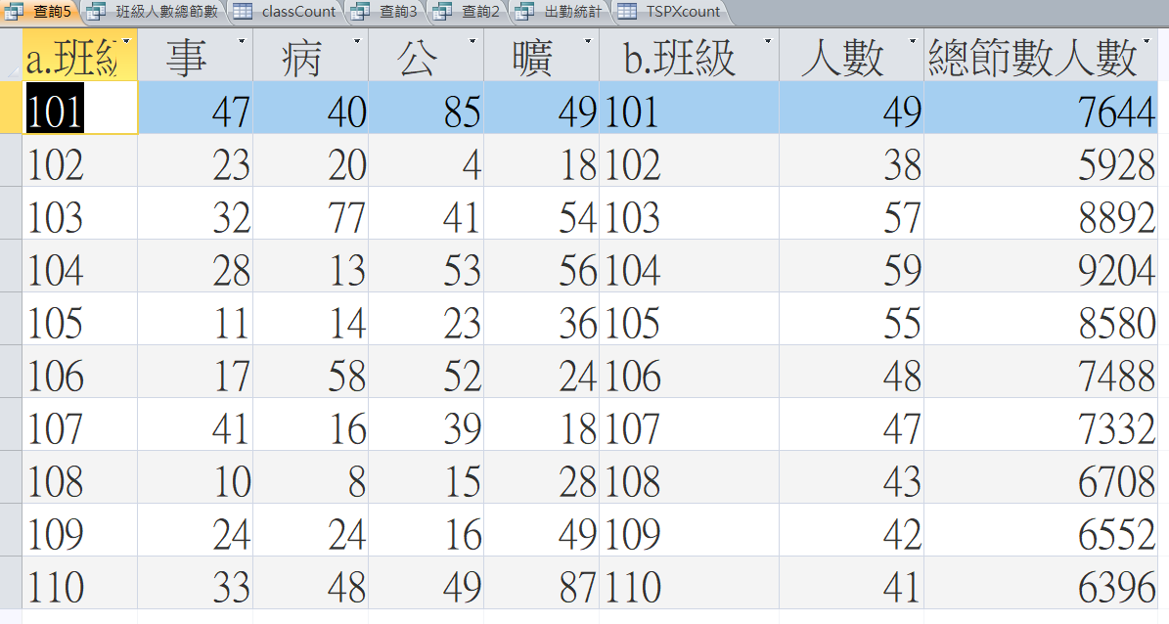

SELECT a.班級,[事],[病],[公],[曠],[人數],[總節數人數],1-([事]+[病]+[公]+[曠])/[總節數人數] as 到課率 FROM TSPXcount AS a, classcount AS b
WHERE a.班級=b.班級 order by a.班級;

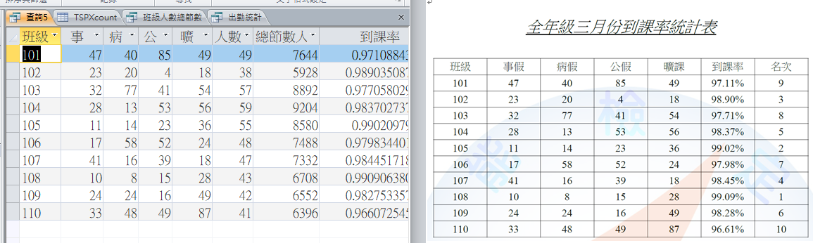

SELECT a.班級,[事],[病],[公],[曠],[人數],[總節數人數],1-([事]+[病]+[公]+[曠])/[總節數人數] as 到課率 into notTSPXrate
FROM TSPXcount AS a, classcount AS b
WHERE a.班級=b.班級 order by a.班級;
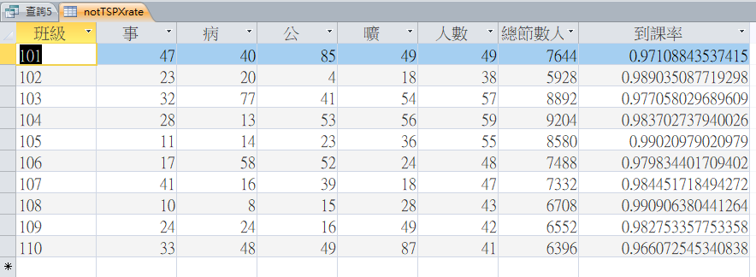

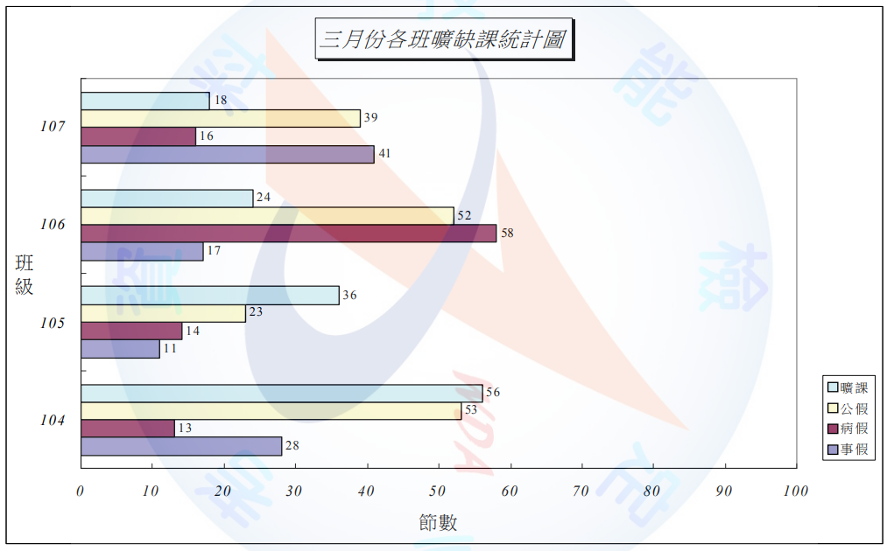

SELECT left([班級座號],3) AS 班級,
sum([事假]) as 事假小計 ,sum( [病假]) as 病假小計,sum( [公假]) as 公假小計, sum([曠課]) as 曠課小計
FROM records
where mid([年月日],3,2)="03" and left([班級座號],3) >= "104" and left([班級座號],3) <= "107"
group by left([班級座號],3)

