20220329在WIN10安裝並使用SQLITE3資料庫及設計C語言連線處理程式
REF 0:https://www.1ju.org/sqlite/installation
REF 1: https://www.itread01.com/content/1546801386.html
REF2: https://www.itread01.com/p/1393649.html
(一)下載、解開並安裝：

Precompiled Binaries for Windows
 | sqlite-dll-win32-x86-3380200.zip  (553.70 KiB) |  | 32-bit DLL (x86) for SQLite version 3.38.2.  (sha3: b61e859ff10f052ae078aefef9a8d783884b8c27eac0be099e15f65d74bbf59c)
 | sqlite-dll-win64-x64-3380200.zip  (994.42 KiB) |  | 64-bit DLL (x64) for SQLite version 3.38.2.  (sha3: 5f3a43c438cb4cc3ac56358e005c7f190105cdd5d3b02910b6818b1dde23f5c3)
 | sqlite-tools-win32-x86-3380200.zip  (1.87 MiB) |  | A bundle of command-line tools for managing SQLite database files, including the command-line shell program, the sqldiff.exe program, and the sqlite3_analyzer.exe program.  (sha3: 0e22e47873902388e3b26c3702fa3cd53ab3f29e315014d7fe25efb0aefbf6bf)

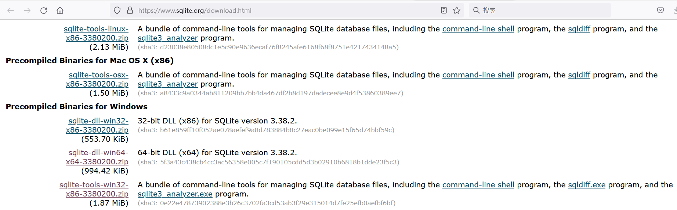

(二)使用sqlite3命列列來建立freeHB2測試資料庫

# sqlite3 freeHB2;
SQLite version 3.38.2 2022-03-26 13:51:10
Enter ".help" for usage hints.
sqlite> CREATE TABLE CUSTS(id char(10),name char(20),amount float,tel char(20));
sqlite> insert into CUSTS(id,name,amount,tel) values ('10001','小狗',100,'233111');
sqlite> insert into CUSTS(id,name,amount,tel) values ('20002','小貓',200,'233444');
sqlite> insert into CUSTS(id,name,amount,tel) values ('30003','小牛',300,'233777');
sqlite> insert into CUSTS(id,name,amount,tel) values ('50001','小龍',100,'233111');
sqlite> update CUSTS SET NAME='SMALLDOG' WHERE NAME='小狗';
sqlite> select * from CUSTS;
10001|SMALLDOG|100.0|233111
20002|小貓|200.0|233444
30003|小牛|300.0|233777
50001|小龍|100.0|233111
sqlite> .quit

(三)編寫測試C語言程式來連線查詢freeHB2資料庫內的CUSTS資料表：
# vi sqlA.c

# cat sqlA.c
// gcc -o sqlA sqlA.c -lsqlite3
#include <stdio.h>
#include <stdlib.h>
#include <sqlite3.h>

//每查到一筆記錄的觸發函數
int ListRecColumns(void *p, int n_column, char **column_value, char **column_name)
{
*(int *)p = 0;
for(int i =0; i < n_column; i++){
printf("%s = %s ", column_name[i],
column_value[i] ? column_value[i] :"NULL");
}
printf("\n");
return 0;
}

int main(int argc, char *argv[])
{
sqlite3 *db;
char *err =0;
int ret =0;
int empty =1;

ret = sqlite3_open("freeHB2",&db);
if(ret !=SQLITE_OK)exit(1);
ret = sqlite3_exec(db, "select * from CUSTS;"
, ListRecColumns, &empty, &err);
if(ret != SQLITE_OK){
sqlite3_close(db);
exit(1);
}

if(empty)exit(1);
sqlite3_close(db);
return 0;
}

編譯
# gcc -o sqlA sqlA.c -lsqlite3
# ls -lt
total 152216
-rwxr-xr-x 1 root root 19712 Mar 26 22:42 sqlA
-rw-r--r-- 1 root root 739 Mar 26 22:42 sqlA.c
-rw-r--r-- 1 root root 8192 Mar 26 21:45 freeHB2

執行
# ./sqlA
id = 10001 name = SMALLDOG amount = 100.0 tel = 233111
id = 20002 name = 小貓 amount = 200.0 tel = 233444
id = 30003 name = 小牛 amount = 300.0 tel = 233777
id = 50001 name = 小龍 amount = 100.0 tel = 233111

