20221109在Fedora32安裝並使用Mediawiki
(1)下載mediawiki-1.38.4.tar.gz
$ sudo wget https://releases.wikimedia.org/mediawiki/1.38/mediawiki-1.38.4.tar.gz
(2)解開mediawiki-1.38.4.tar.gz
$ sudo tar xvzf mediawiki-1.38.4.tar.gz
(3)將解開的主資料夾mediawiki-1.38.4改名為kia
$ sudo mv mediawiki-1.38.4 kia
(4)執行http://lfwiki.kmvs.km.edu.tw/kia/網頁安裝，出現如下錯誤：

MediaWiki 1.38 internal error

:
You are missing a required extension to PHP that MediaWiki requires to run. Please install:
- intl (more information)

(5A) $ sudo yum --enablerepo=remi install php-intl

(5B) sudo vi /usr/local/php/lib/php.ini
extension=intl.so
(5C)sudo ls /etc/php.d/
10-opcache.ini 20-intl.ini 20-sqlite3.ini 30-pdo_sqlite.ini
:
20-iconv.ini 20-sodium.ini 30-pdo_pgsql.ini

(6) $ sudo systemctl restart php-fpm

(7) $sudo /usr/local/apache2/bin/apachectl restart

(8) $ cat /usr/local/apache2/logs/error_log
PHP Warning: PHP Startup: Unable to load dynamic library '/usr/local/php/lib/php/extensions/no-debug-zts-20121212/intl.so' - /usr/local/php/lib/php/extensions/no-debug-zts-20121212/intl.so: cannot open shared object file: No such file or directory in Unknown on line 0
[Tue Nov 08 22:58:51.059370 2022] [mpm_event:notice] [pid 717202:tid 140075689749376] AH00489: Apache/2.4.54 (Unix) PHP/5.5.16 configured -- resuming normal operations
[Tue Nov 08 22:58:51.059419 2022] [core:notice] [pid 717202:tid 140075689749376] AH00094: Command line: '/usr/local/apache2/bin/httpd'

(9A) $ ls /usr/local/php/lib/php/extensions/no-debug-zts-20121212/
opcache.so

(9B) $ ls -l /usr/lib64/php/modules/|grep intl
-rwxr-xr-x 1 root root 490504 May 4 2021 intl.so

(9c) $ sudo cp /usr/lib64/php/modules/intl.so /usr/local/php/lib/php/extensions/no-debug-zts-20121212/

$ sudo cp /usr/lib64/php/modules/intl.so /usr/local/php/lib/php/extensions/no-debug-non-zts-20210902

(9D) $ ls /usr/local/php/lib/php/extensions/no-debug-zts-20121212/ -l
total 1072
-rwxr-xr-x 1 root root 490504 Nov 9 21:43 intl.so
-rwxr-xr-x. 1 root root 602688 Oct 18 2020 opcache.so
$ sudo ls /usr/local/php/lib/php/extensions/no-debug-non-zts-20210902
intl.so opcache.so

(10A) $ sudo /usr/local/apache2/bin/apachectl restart

(10B) $ sudo systemctl restart php-fpm

(10C)$ cat /usr/local/apache2/logs/error_log
:
PHP Warning: PHP Startup: Unable to load dynamic library '/usr/lib64/php/modules/intl.so' - /usr/lib64/php/modules/intl.so: undefined symbol: zend_string_init_interned in Unknown on line 0
[Wed Nov 09 21:44:55.906442 2022] [mpm_event:notice] [pid 717202:tid 140075689749376] AH00489: Apache/2.4.54 (Unix) PHP/5.5.16 configured -- resuming normal operations

(11A)$ which php
/usr/local/php/bin/php

(11B)$ ll /usr/local/php/bin/php
-rwxr-xr-x 1 root root 57662352 Nov 9 03:07 /usr/local/php/bin/php

(11C) $ /usr/local/php/bin/php -v
PHP Warning: PHP Startup: Unable to load dynamic library 'intl.so' (tried: /usr/local/php/lib/php/extensions/no-debug-non-zts-20210902/intl.so (/usr/local/php/lib/php/extensions/no-debug-non-zts-20210902/intl.so: undefined symbol: _call_user_function_ex), :
Zend Engine v4.1.12, Copyright (c) Zend Technologies

(11D) $ phpize -v
Configuring for:
PHP Api Version: 20210902
Zend Module Api No: 20210902
Zend Extension Api No: 420210902

(11E)$ whereis phpize
phpize: /usr/bin/phpize /usr/local/bin/phpize /usr/local/php/bin/phpize /usr/share/man/man1/phpize.1.gz

(11F)$ php -r "echo ini_get('extension_dir');"
PHP Warning: PHP Startup: Unable to load dynamic library '/usr/lib64/php/modules/intl.so' (tried: /usr/lib64/php/modules/intl.so (/usr/lib64/php/modules/intl.so: undefined symbol: _call_user_function_ex), /usr/local/php/lib/php/extensions/no-debug-non-zts-20210902//usr/lib64/php/modules/intl.so.so (/usr/local/php/lib/php/extensions/no-debug-non-zts-20210902//usr/lib64/php/modules/intl.so.so: cannot open shared object file: No such file or directory)) in Unknown on line 0

(11G)$ sudo dnf install php-intl
:
Package php-intl-7.4.19-1.fc32.x86_64 is already installed.
Dependencies resolved.
Nothing to do.
Complete!

(12) $ sudo dnf install php-devel
:
Upgraded:
krb5-libs-1.18.2-29.fc32.x86_64 pcre2-10.36-4.fc32.x86_64
pcre2-syntax-10.36-4.fc32.noarch
Installed:
keyutils-libs-devel-1.6-4.fc32.x86_64
krb5-devel-1.18.2-29.fc32.x86_64
libcom_err-devel-1.45.5-3.fc32.x86_64
libedit-devel-3.1-32.20191231cvs.fc32.x86_64
libkadm5-1.18.2-29.fc32.x86_64
libselinux-devel-3.0-5.fc32.x86_64
libsepol-devel-3.0-4.fc32.x86_64
libverto-devel-0.3.0-9.fc32.x86_64
pcre2-devel-10.36-4.fc32.x86_64
pcre2-utf16-10.36-4.fc32.x86_64
pcre2-utf32-10.36-4.fc32.x86_64
php-devel-7.4.19-1.fc32.x86_64

Complete!
(13)$ php -m | grep intl
:
Intl

(14) http://lfwiki.kmvs.km.edu.tw/kia/
MediaWiki 1.38.4
LocalSettings.php not found.
Please set up the wiki first.
(15)電腦系統語言及WIKI語言接受預設的zh-tw 中文(台灣)

(16)環境檢查：PHP 8.1.12 已安裝。警告：找不到APCu或WinCache。未開啟物件快取。找到 ImageMagick：/usr/bin/convert。若您開啟了檔案上傳功能，將可啟用縮圖功能。
查無 Git 版本控制軟體，而您現在可忽略它，另外請注意 Special:Version 不會顯示出提交的雜湊。
使用伺服器名稱 "http://lfwiki.kmvs.km.edu.tw"。
使用伺服器 URL "http://lfwiki.kmvs.km.edu.tw/kia"。
使用 PHP intl 擴充套件做 Unicode 正規化。
環境檢查已完成。 您可以安裝 MediaWiki。
(17) 資料庫類型接受預設的MariaDB，並輸入如下設定
資料庫主機：127.0.0.1、資料庫名稱：kiaDB、資料庫資料表名字首：kiaA
安裝程式採用的資料庫使用帳號為root及其密碼

(18)接受「供網頁存取使用的資料庫帳號同安裝程序所用的帳號」

(19)wiki的名稱為「金門農工維基III」、管理員帳號為tree，密碼目前給定。
(20) 使用者權限採「需要註冊帳號」，授權採CC0。
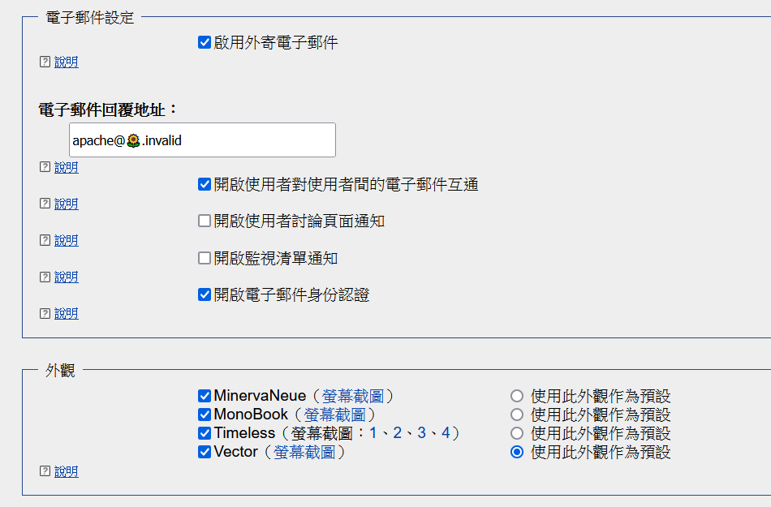
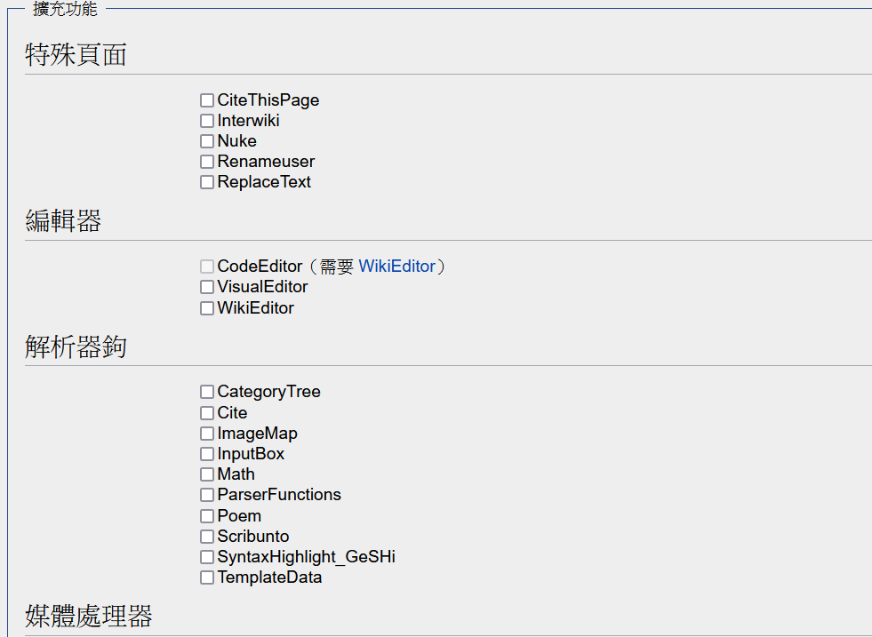
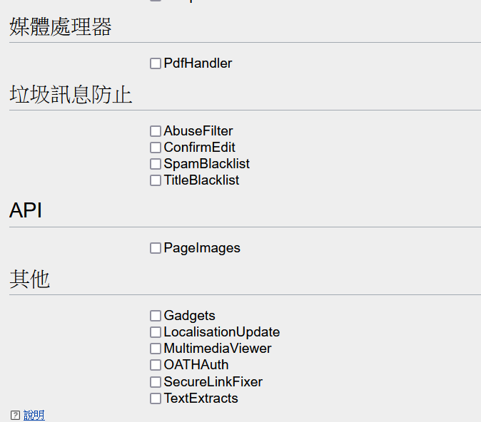
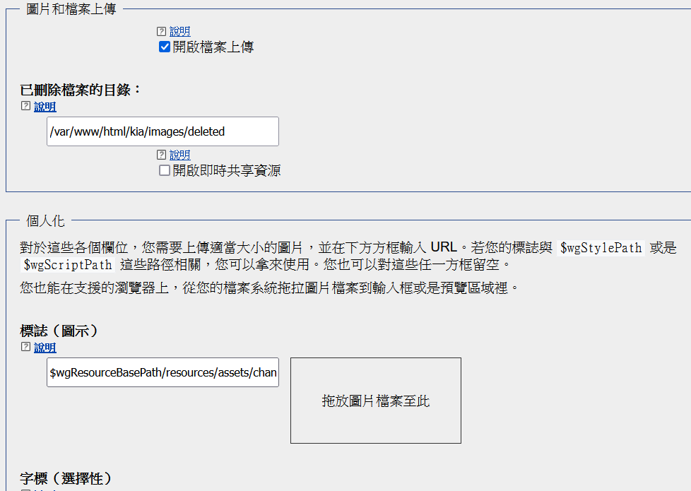
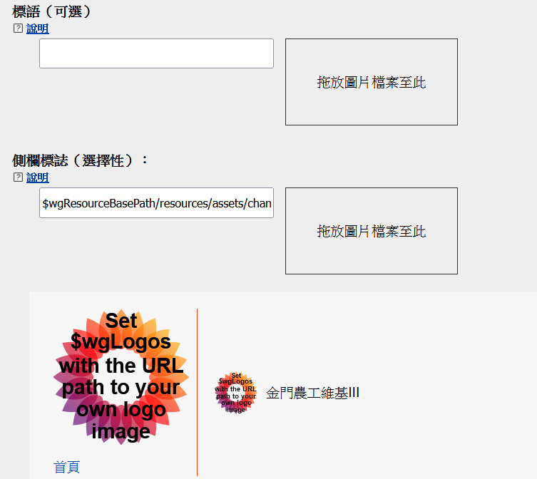
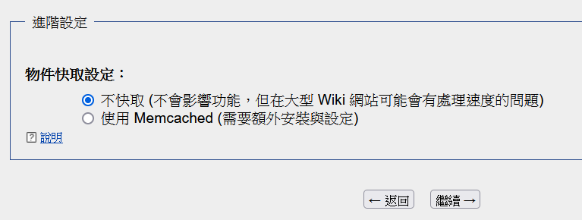

(21)啟動安裝

(22) 安裝中…

- 正在設定資料庫…完成
- 正在建立資料表，步驟一…完成
- 正在建立資料庫使用者…完成
- 正在建立資料表，步驟二…完成
- 正在匯入預設的跨wiki資料表…完成
- 初始化統計資訊…完成
- 正在產生密鑰…完成
- 略過執行不需要的更新…完成
- 恢復 mediawiki 服務…完成
- 正在建立管理員使用者帳號…完成
- 正在使用預設的內容建立首頁…完成
資料庫設定成功

(23)完成！
恭喜！ 您已經成功安裝MediaWiki。
安裝程式已自動產生LocalSettings.php檔案， 該檔案中包含了您所有的設定項目。
您需要下載該檔案，並將其放置在您 wiki 的根目錄（index.php 所在的目錄）中，下載應已自動開始。
若瀏覽器沒有提示您下載，或者您取消了下載，您可以點選下方連結重新下載：
下載 LocalSettings.php
注意：如果您現在不下載此檔案，稍後結束安裝程式之後將無法再下載設定檔。
當您完成本步驟後，您可以進入您的 wiki。

(23B) sudo vi LocalSettings.php 並貼入下載 LocalSettings.php的內容

(24)用firefox 開啟 http://lfwiki.kmvs.km.edu.tw/kia 成功並順利以
最高用戶Tree登入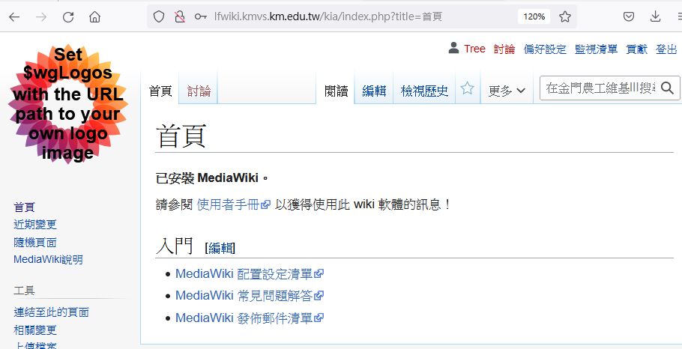

(二)資料庫轉移：
(1) $ sudo cat /usr/local/apache2/htdocs/kmvswiki2_bak/LocalSettings.php| grep kmvswiki
$wgScriptPath = "/kmvswiki2";
$wgDBname = "kmvswiki2DB";
$wgDBprefix = "kmvswiki2";
$wgUploadDirectory = "$IP/kmvswiki2/images";

(2) sudo mysqldump -h 127.0.0.1 -u root -p --default-character-set=utf8 kmvswiki2DB > 20221115wikibackup.sql

(3) $ stat 20221115wikibackup.sql
File: 20221115wikibackup.sql
Size: 61993152 Blocks: 121088 IO Block: 4096 regular file
Device: fd00h/64768d Inode: 19603539 Links: 1
Access: (0664/-rw-rw-r--) Uid: ( 1000/ admin) Gid: ( 1000/ admin)
Access: 2022-11-15 01:39:31.066127752 -0500
Modify: 2022-11-15 01:38:38.512004762 -0500
Change: 2022-11-15 01:38:38.512004762 -0500
Birth: -

(4) sudo mysql -u root -p kiaADB < 20221115wikibackup.sql

https://www.mediawiki.org/wiki/Manual:Restoring_a_wiki_from_backup

(5) $ stat /usr/local/apache2/htdocs/kia/maintenance/update.php
File: /usr/local/apache2/htdocs/kia/maintenance/update.php
Size: 8919 Blocks: 24 IO Block: 4096 regular file
Device: fd00h/64768d Inode: 11180780 Links: 1
Access: (0775/-rwxrwxr-x) Uid: ( 1000/ admin) Gid: ( 1000/ admin)
Access: 2022-11-08 22:26:40.773586269 -0500
Modify: 2022-09-29 16:39:53.881056500 -0400
Change: 2022-11-08 22:26:40.773586269 -0500
Birth: -

(6) $ php /usr/local/apache2/htdocs/kia/maintenance/update.php
:

Done in 2.1 s.

(7) $ mysql -p -uroot
MariaDB [(none)]> use kiaADB;
MariaDB [kiaADB]> show tables;
+--------------------------------+
| Tables_in_kiaADB |
+--------------------------------+
| kiaAactor |
| kiaAarchive |
| kiaAbot_passwords |
| kiaAcategory |
| kiaAcategorylinks |
| kiaAchange_tag |
| kiaAchange_tag_def |
| kiaAcomment |
| kiaAcontent |
| kiaAcontent_models |
| kiaAexternallinks |
| kiaAfilearchive |
| kiaAimage |
| kiaAimagelinks |
| kiaAinterwiki |
| kiaAip_changes |
| kiaAipblocks |
| kiaAipblocks_restrictions |
| kiaAiwlinks |
| kiaAjob |
| kiaAl10n_cache |
| kiaAlanglinks |
| kiaAlinktarget |
| kiaAlog_search |
| kiaAlogging |
| kiaAmodule_deps |
| kiaAobjectcache |
| kiaAoldimage |
| kiaApage |
| kiaApage_props |
| kiaApage_restrictions |
| kiaApagelinks |
| kiaAprotected_titles |
| kiaAquerycache |
| kiaAquerycache_info |
| kiaAquerycachetwo |
| kiaArecentchanges |
| kiaAredirect |
| kiaArevision |
| kiaArevision_actor_temp |
| kiaArevision_comment_temp |
| kiaAsearchindex |
| kiaAsite_identifiers |
| kiaAsite_stats |
| kiaAsites |
| kiaAslot_roles |
| kiaAslots |
| kiaAtemplatelinks |
| kiaAtext |
| kiaAupdatelog |
| kiaAuploadstash |
| kiaAuser |
| kiaAuser_former_groups |
| kiaAuser_groups |
| kiaAuser_newtalk |
| kiaAuser_properties |
| kiaAwatchlist |
| kiaAwatchlist_expiry |
| kmvswiki2actor |
| kmvswiki2archive |
| kmvswiki2bot_passwords |
| kmvswiki2category |
| kmvswiki2categorylinks |
| kmvswiki2change_tag |
| kmvswiki2change_tag_def |
| kmvswiki2comment |
| kmvswiki2content |
| kmvswiki2content_models |
| kmvswiki2externallinks |
| kmvswiki2filearchive |
| kmvswiki2image |
| kmvswiki2imagelinks |
| kmvswiki2interwiki |
| kmvswiki2ip_changes |
| kmvswiki2ipblocks |
| kmvswiki2ipblocks_restrictions |
| kmvswiki2iwlinks |
| kmvswiki2job |
| kmvswiki2l10n_cache |
| kmvswiki2langlinks |
| kmvswiki2log_search |
| kmvswiki2logging |
| kmvswiki2module_deps |
| kmvswiki2objectcache |
| kmvswiki2oldimage |
| kmvswiki2page |
| kmvswiki2page_props |
| kmvswiki2page_restrictions |
| kmvswiki2pagelinks |
| kmvswiki2protected_titles |
| kmvswiki2querycache |
| kmvswiki2querycache_info |
| kmvswiki2querycachetwo |
| kmvswiki2recentchanges |
| kmvswiki2redirect |
| kmvswiki2revision |
| kmvswiki2revision_actor_temp |
| kmvswiki2revision_comment_temp |
| kmvswiki2searchindex |
| kmvswiki2site_identifiers |
| kmvswiki2site_stats |
| kmvswiki2sites |
| kmvswiki2slot_roles |
| kmvswiki2slots |
| kmvswiki2templatelinks |
| kmvswiki2text |
| kmvswiki2updatelog |
| kmvswiki2uploadstash |
| kmvswiki2user |
| kmvswiki2user_former_groups |
| kmvswiki2user_groups |
| kmvswiki2user_newtalk |
| kmvswiki2user_properties |
| kmvswiki2watchlist |
| kmvswiki2watchlist_expiry |
+--------------------------------+
115 rows in set (0.001 sec)
MariaDB [kiaADB]> quit

(8)$ sudo vi LocalSettings.php

$ sudo cat LocalSettings.php |grep kmvs
$wgServer = "http://lfwiki.kmvs.km.edu.tw";
$wgDBprefix = "kmvswiki2";

